# Documentation – Admin Portal

# Introduction

The admin portal for the SecureBiz website, will grant authorised users the ability to edit, add or List Mitigation for each of the eight mitigation strategies. This provides an authorized access to all the admin users of the website by providing username and password for each admin user.

# Details

Some of the functions of the admin portal are still to be tested fully, however this report will document what the page is currently capable of and what it will be capable of in future iterations. Currently the admin portal will be accessible via a tab on the top of the page which can only be accessed by the ‘admin portal’ of the webpage.

Currently there are **two** options that are available:

**Manage Mitigation Strategies** – This will allow the admin to List the mitigations questions, edit each of the questions, add new questions along with mitigation for the wrong answer. To do any of the following tasks the user needs to login first. The below picture represents the **Login portal**

After the admin login there will be three options listed to the user as shown below:

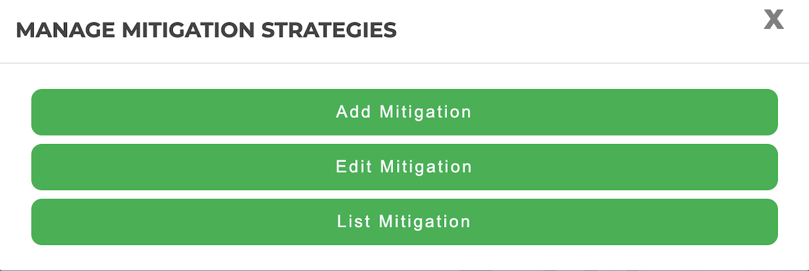

Once the Admin click on any one option, a list of 8 mitigation strategies are displayed as shown below. The admin can choose any and do the required.

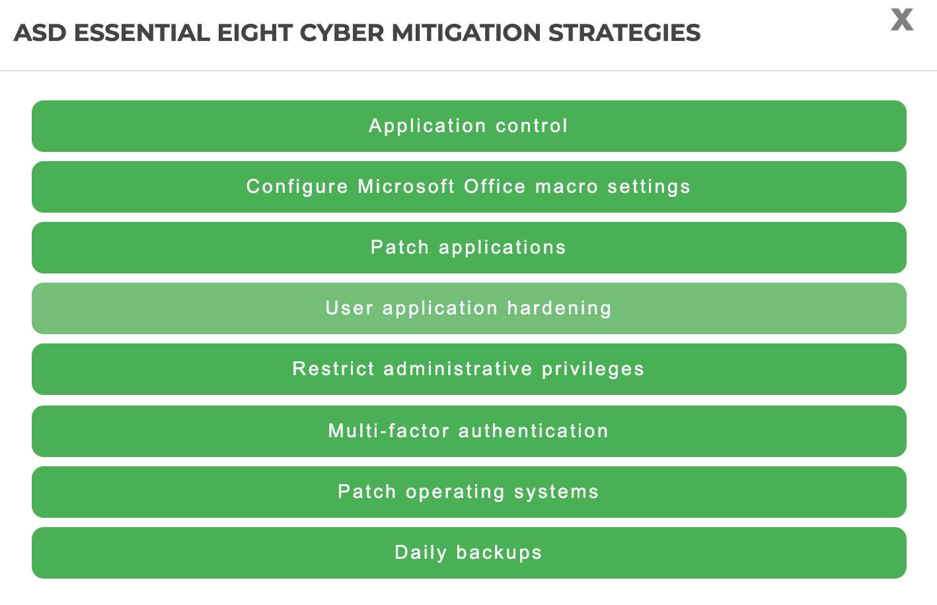

**When Admin choose to add question:** The picture below represents how the administrator will be able to add new question, Its description, details and mitigation for No selection.

**When Admin Choose to Edit Mitigation:** The below picture represents how the things will appear when the admin wants to edit any question for the selected mitigation strategy.

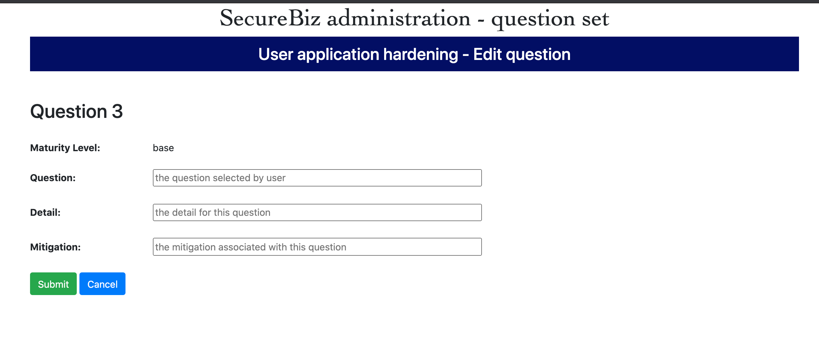

When admin choose to List Mitigation: The below picture represents how the things will appear when the admin wants to list the mitigation for the selected mitigation strategy.

